**Project Pegasus 2022 Q4 Update**

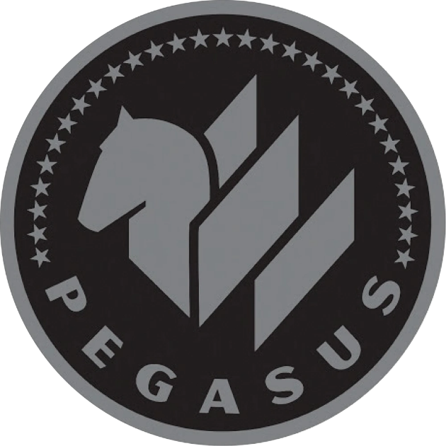

* The rebuilding of the New Mexico facility is ahead of schedule and should be completed by Q2 next year.
* NASA has agreed to allow cleared employees from Space X to consult on Project Pegasus on a limited basis.
* Some of the recent Pacific Coast UFO sightings are tied to our Valkyrie project, but a handful are of unknown origin and are being investigated appropriately.
* The recent stability improvements in Iso-8 may unlock it’s potential as a propulsion system and project Cox should begin testing next year.